Issue with virtualizing MongoDB using the Delphix SDK. 7/9/2019.

We are able to start the MongoDB service when the dbPath is on the local drive.
Note mongod_var_lib_t.
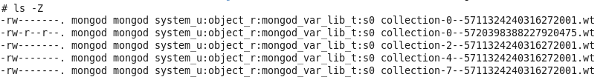
When we point the /etc/mongod.conf:dbPath to the Delphix mounted vFile directory mounted Delphix the MongoDB service fails to start due to permissions.
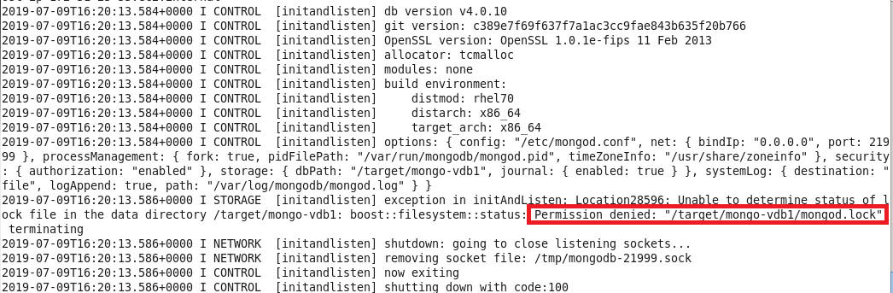
When you look at the context of the files on the VDB mount.
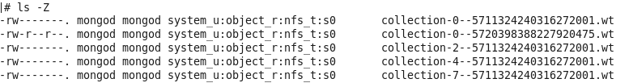
Note that the context type ‘nfs_t’ of the Delphix mount is different than the type on the local filesystem which is ‘mongod_var_lib_t’. More info on linux context types can be found at https://access.redhat.com/documentation/en-us/red_hat_enterprise_linux/6/html/security-enhanced_linux/chap-security-enhanced_linux-selinux_contexts.
When I try to change the type of the files on the mount I get the following errors.
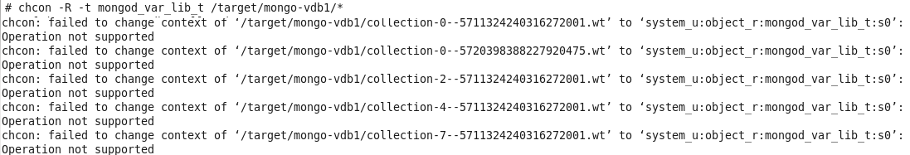
I then copied (i.e. tar) the files to a local file system, changed the type successfully, pointed /etc/mongod.conf:dbPath to it, and tried to start the service and it started fine. So the conclusion is that we need to find a way that we can recursively change the type of the mount point folder from ‘nfs_t’ to ‘mongod_var_lib_t’.

