Enabling public key authentication for Delphix Engine is strongly recommended for the processes documented in this document.
Without public key authentication, Delphix will prompt for a password for each CLI command:
CLI Cookbook: Configuring Key-Based SSH Authentication for Automation
DISABLING VDBs

# Generate list with commands to disable VDBs
# DELETE VDBs that should not be disabled by adding the strings in egrep

echo "/source list display=name,virtual,config" | ssh admin@10.160.1.5 | grep true |egrep -v "dx|staging|AppFS|Postgres|ORA|MySQL" | awk '{print "/source; select "$1";disable; set type=SourceDisableParameters; commit"}' > /tmp/disable_VDBs.out

# Edit the list of VDBs to confirm that the list is correct
vi /tmp/disable_VDBs.out

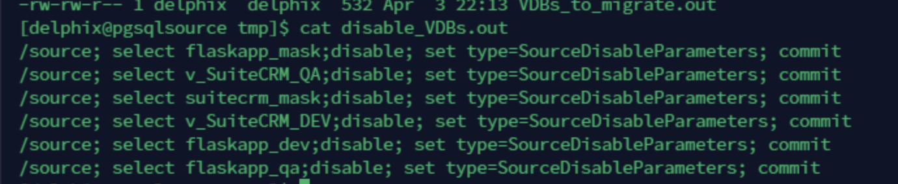

#Run the command below to disable the VDBs

while read in; do echo "$in" | ssh admin@10.160.1.5; done < /tmp/disable_VDBs.out

CHANGING THE SQL SERVER OF THE VDBs

# After disabling the VDBs, generate the commands to change the MSSQL server
# Change the value of the repository for the target server/instance
# DELETE the VDBs that should not be migrated by adding the strings in egrep

echo "/source list display=name,virtual,config" | ssh admin@10.160.1.5 | grep true |egrep -v "dx|staging|AppFS|Postgres|ORA|MySQL" | awk '{print "/sourceconfig; select "$1";update; set environmentUser=NEW_HOST/user_name;set repository=NEW_HOST/NEW_INSTANCE; commit"}' > /tmp/VDBs_to_migrate.out

# DELETE the VDBs that should not be migrated by adding the strings in egrepvi /tmp/ VDBs_to_migrate.out

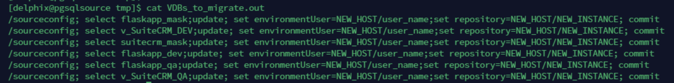

RE-enabling VDBs

# Generate the commands to reactivate the VDBs:

echo "/source list display=name,virtual,config" | ssh admin@10.160.1.5 | grep true |egrep -v "dx|staging|AppFS|Postgres|ORA|MySQL" | awk '{print "/source; select "$1";enable; set type=SourceEnableParameters; commit"}' > /tmp/enable_VDBs.out

# Edit the list to confirm that the commands are correct:

vi /tmp/enable_VDBs.out

# Edit the list to confirm that the commands are correct:

while read in; do echo "$in" | ssh admin@10.160.1.5; done < /tmp/enable_VDBs.out

